Uganda Marine Police- Annual Crime Report 2025

1. Overview of Crime Situation in 2025
The number of reported cases decreased by 33.7% in 2025, dropping from 190 cases in 2024 to 126 cases in 2025. Despite the overall reduction, marine incidents continue to carry substantial operational weight because they involve a high risk to life, demand specialized response capability, and require extensive logistical resources.
During 2025, the Marine Unit handled incidents under the following major categories:
Table 1: Summary of Reported Incidents by Category, 2025
Type of Incident | Percentage frequency of INCIDENT
Abduction | 0.79%
Aggravated Robbery | 6.35%
Aggravated Robbery and Murder | 2.38%
Attempted murder | 1.59%
Boat arson | 0.79%
Boat breakdown | 0.79%
Boat capsizing | 1.59%
Crocodile killing | 0.79%
Drowning | 64.29%
Engine failure | 0.79%
Fatal Accident | 1.59%
Hippopotamus killing | 0.79%
Murder | 3.17%
Murder and Robbery | 0.79%
Robbery | 8.73%
Stranding | 1.59%
Theft | 2.38%
Wrecked boat | 0.79%
Grand Total | 100.00%

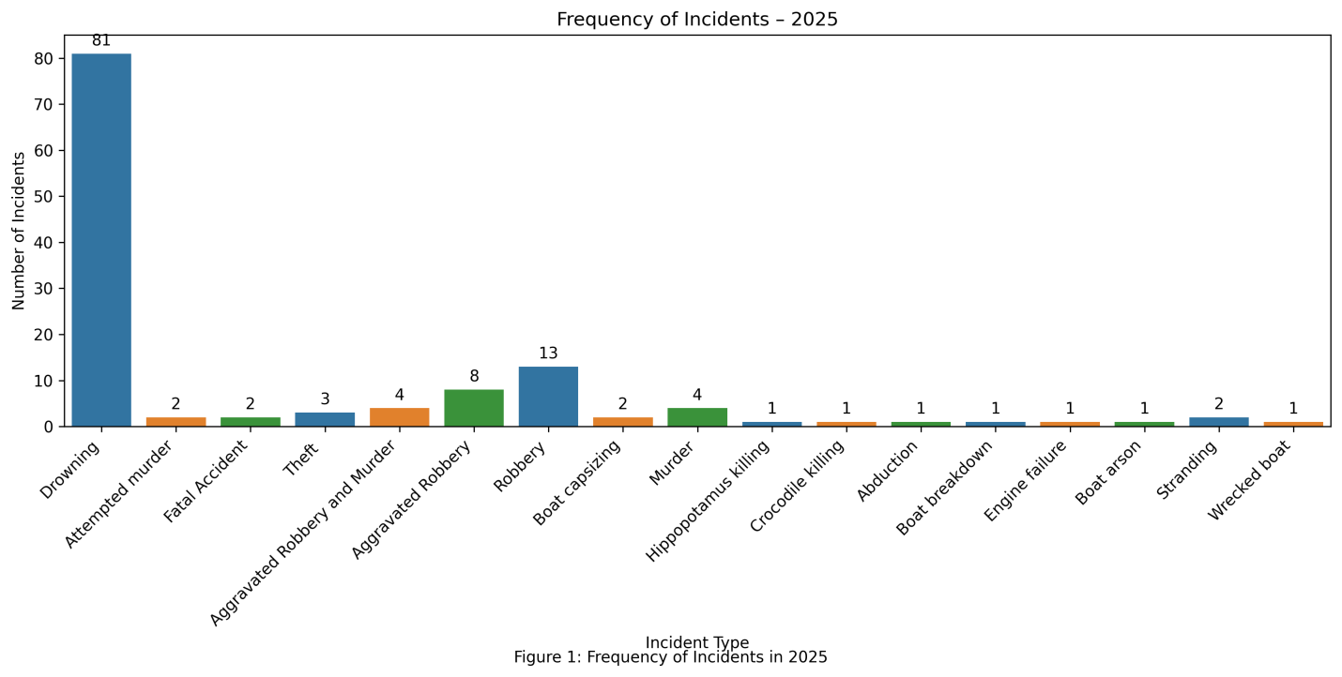

2. Analysis by Crime/Incident Category

2.1 Drowning
Drowning was the most frequently reported incident during the year as shown in Figure 1 above.
Primary Causes included:
- boat capsizing due to bad weather
- man overboard
- heavy tides
- inability to swim
- suicide
- alcohol influence
- overloading
- entry into deep waters by non-swimmers
- washing or bathing at the shore
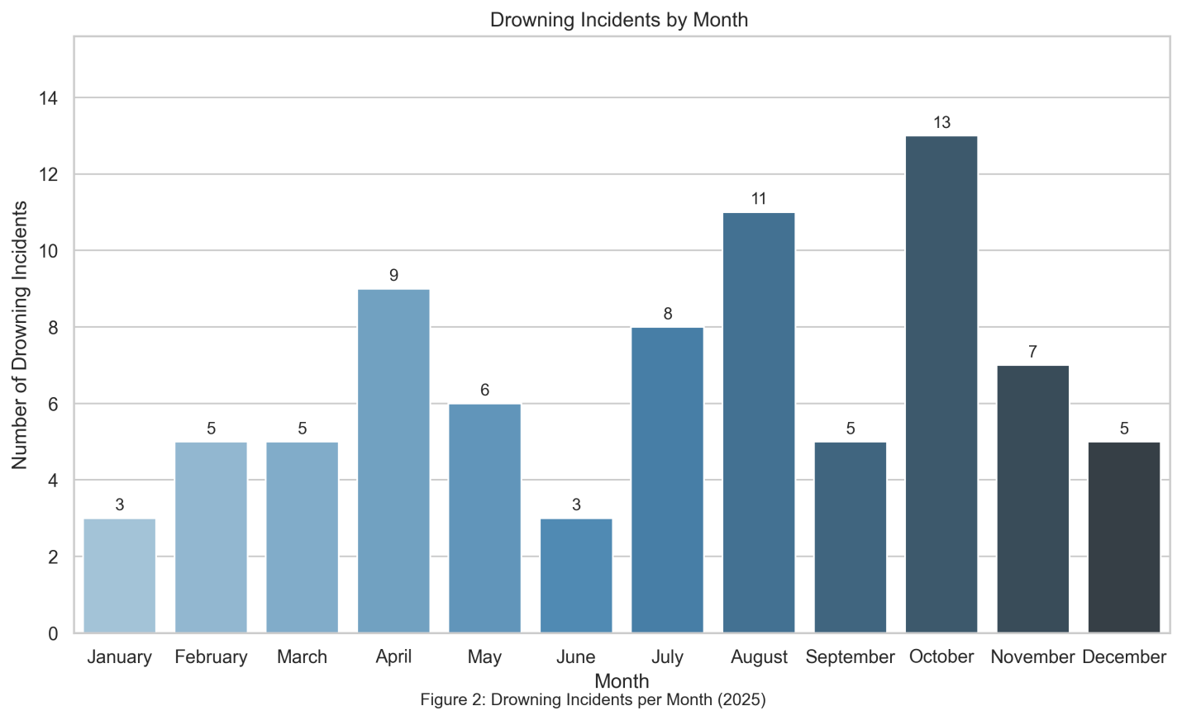
During the year under review, the month of October recorded the highest number of drowning incidents, indicating a peak in marine-related emergencies during this period. This was followed by the months of August, April and July, which also registered relatively high case numbers compared to the rest of the year. The trend may be attributed to increased fishing activities associated with seasonal variations. The pattern highlights the need for targeted enforcement and sensitization interventions in these peak periods to mitigate the occurrence of drowning incidents.

2.2 Robbery and Aggravated Robbery
A total of twenty-four (24) robbery incidents were recorded during the reporting period. The stolen items primarily included outboard engines and fishing nets, indicating a targeted pattern against fishermen. Analysis of incident locations shows that the majority of these robberies occurred within the Victoria Northeast Zone (refer to the figure below).
Some robberies were accompanied by murder or assault.
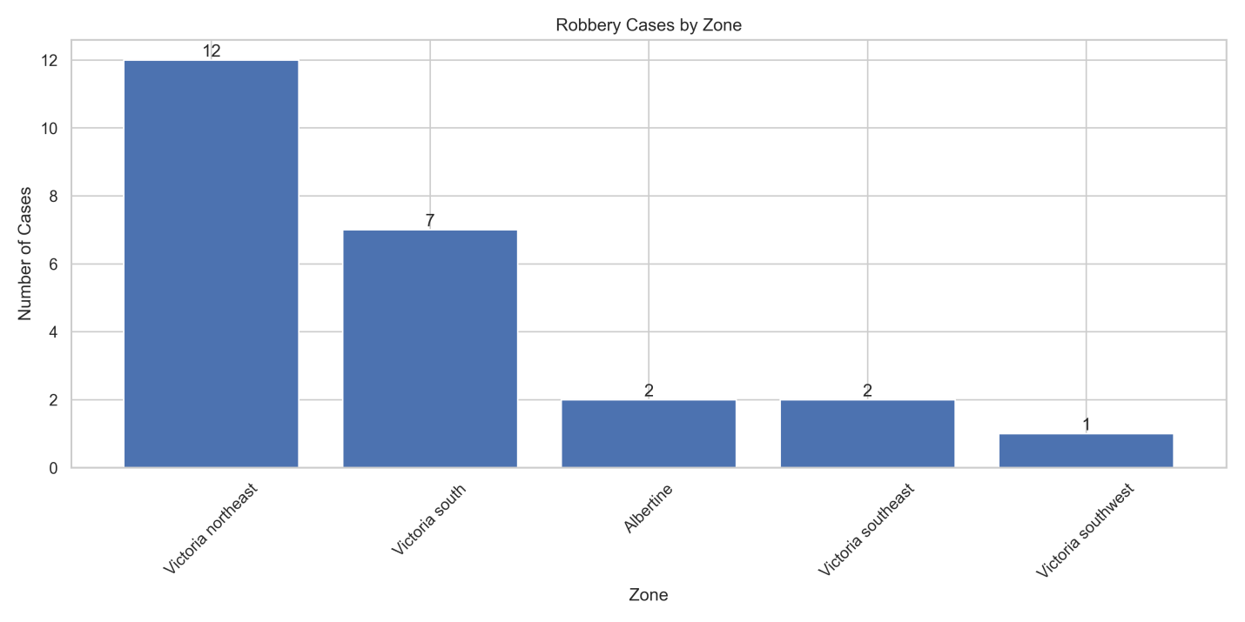

2.3 Murder and Attempted Murder

A total of 8 murder cases were reported and most cases took place in Kyoga Zone followed by Victoria northeast and Victoria south.
Murder incidents were reported in relation to:
- outright criminality
- disputes among fishermen
- piracy-style attacks on water
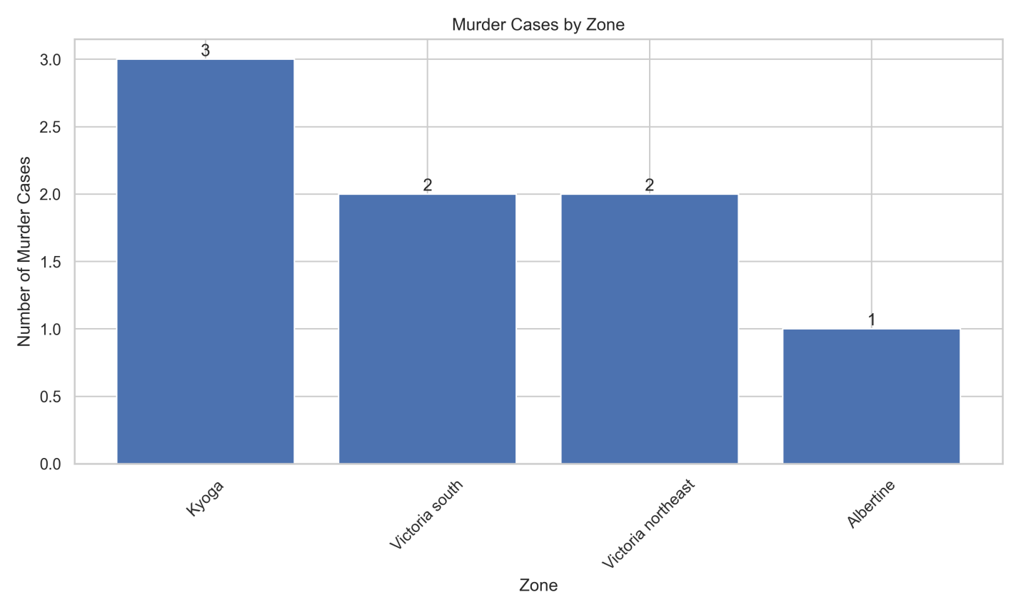

2.4 Wildlife-Related Incidents

Two (2) fatal wildlife-related incidents were reported during the period under review, comprising one (1) hippopotamus attack and one (1) crocodile attack.

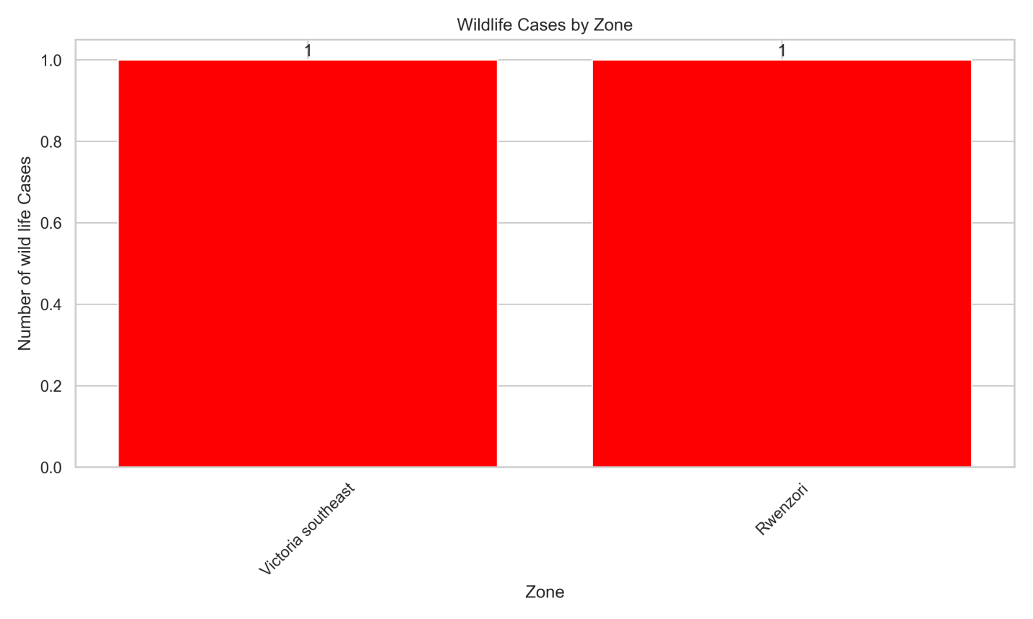

3. Marine Safety and Rescue Operations
The Marine Unit undertook:
- rescue of survivors
- recovery of bodies
- evacuation of stranded passengers
- towing of distressed vessels
- public sensitization on life jacket use
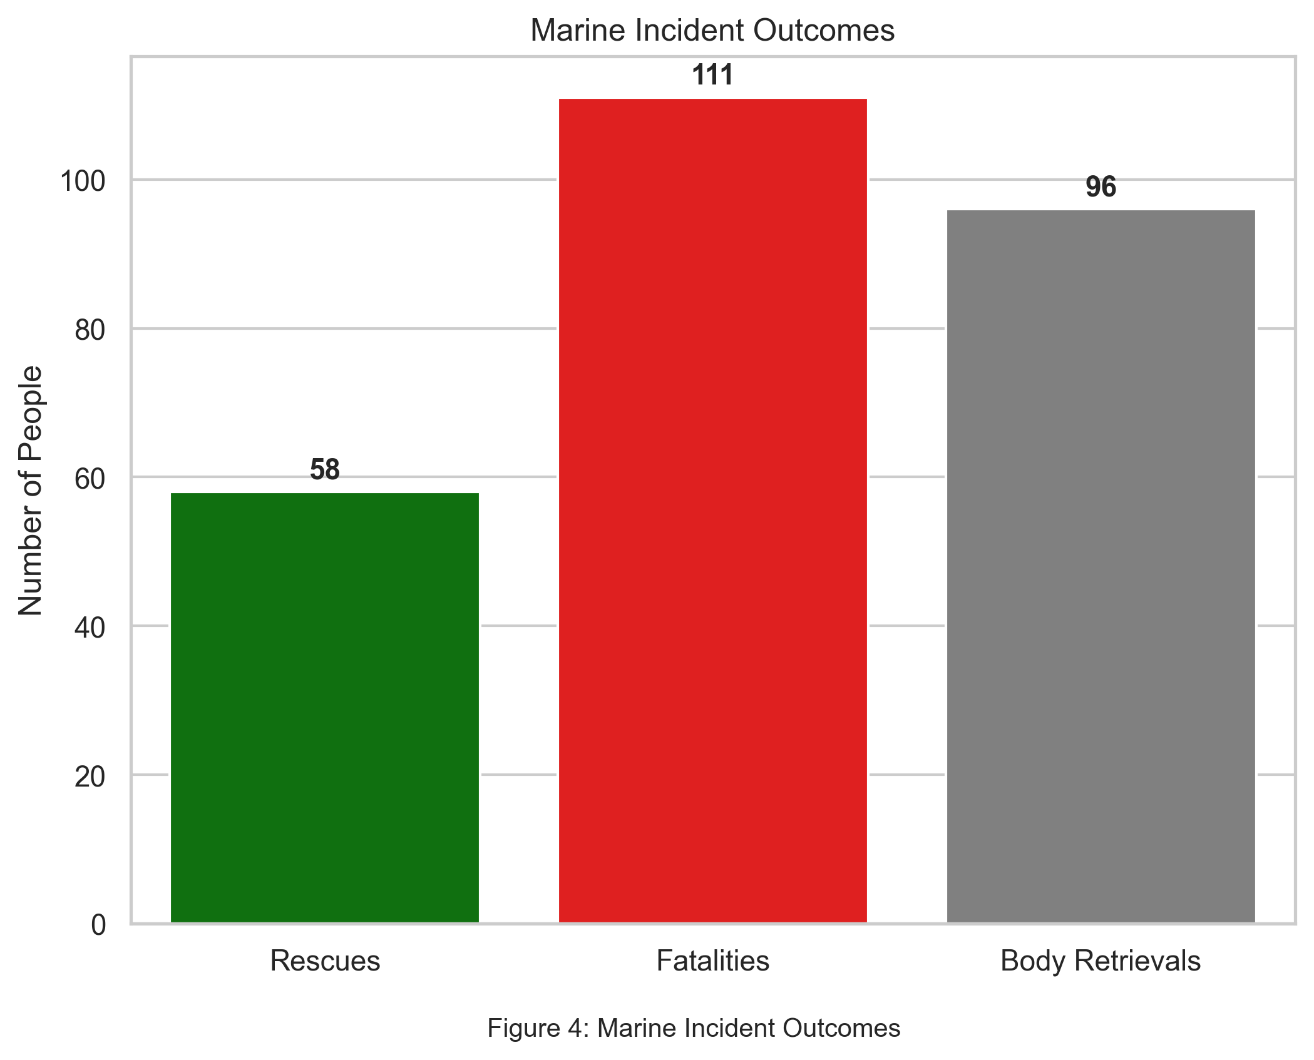
The Marine police also prioritized rapid response to emergencies, which contributed to thee significant number of rescues recorded, as illustrated in figure 4.

4. Distribution of Incidents by Lakes
Incidents occurred across all major lakes as shown in figure 5:
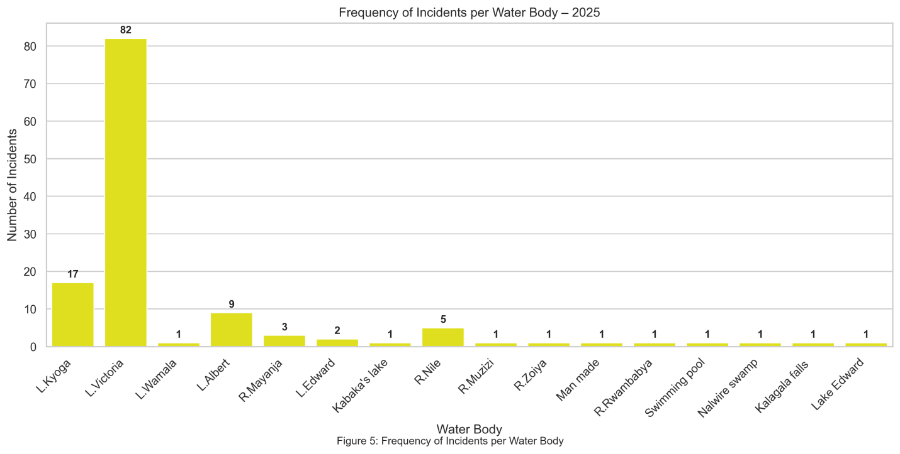
Lake Victoria registered the highest number of incidents, followed by Lake Kyoga, indicating that these water bodies remain the most affected and require more heightened attention in terms of safety and enforcement interventions.

5. Notable Cases
- multiple fatalities from capsized fishing vessels
- recovery of bodies after heavy tides incidents
- engine robberies involving cross-border operatives
- cases involving wildlife attacks
- suicide cases on water
- abduction on Lake Albert

6. Strategies Taken to Reduce Marine Incidents
The unit implemented a range of proactive strategies aimed at reducing marine incidents during the year. These included intensified routine patrols across major water bodies, increased community policing and sensitization on water safety, and strict enforcement of maritime laws and regulations. The unit strengthened collaboration with local leaders, beach management units, and other stakeholders to enforce reporting and early response to incidents. Emphasis was also placed on promoting the use of lifejackets, safe vessel loading practices, and discouraging alcohol consumption while on water. Additionally, capacity- building initiatives such as training of crews and first responders improved readiness and response time, contributing significantly to the reduction and effective management of marine incidents.
6.1 Community Engagements
During the reporting period, the Marine Unit successfully held over 90 community policing forums including radio/TV Shows aimed at sensitizing communities on marine safety, drowning prevention, and crime reporting.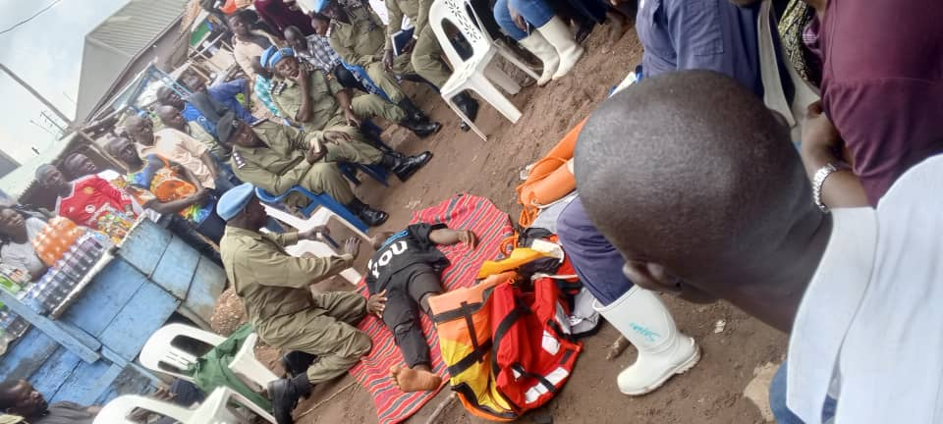
1: An officer demonstrated the provision of first aid to an unconscious person during a community policing engagement in Katosi, emphasizing emergency response skills and public safety awareness

6.2 Opening of Bukasa Detach
The commissioning of the Bukasa Detach(presided over by the commandant marine CP/Hajji Kirungi Sulaiman) marked a major milestone in expanding marine policing presence and accessibility. The detachment improves command coverage in the Bukasa area, enhances response time to incidents, and strengthens community engagement along the lakeshore. The facility also serves as a forward operating base for patrols and emergency operations within the surrounding waters.
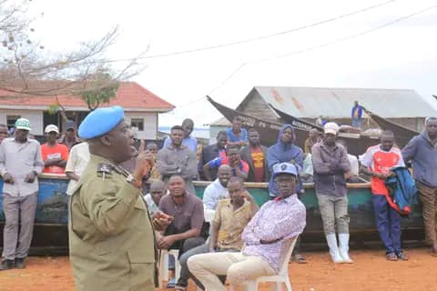
pic 1: The Commandant of the Marine unit, CP Hajj Kirungi Sulaiman, addressed the residents of Bukasa during the official opening of the Bukasa Detachment
6.3 Capacity Building of Marine Personnel
A number of trainings were carried out to build capacity of the officers in various areas.

6.3.1 Types of Training Conducted
a) Induction/Orientation Training
New officers were oriented on organizational structure, roles, code of conduct, and standard operating procedures.
b) Refresher Training
serving officers received refresher training to update skills, reinforce procedures, and address noted performance gaps.

c) Specialized/Technical Training
specialized training was conducted in areas such as:
- Diving
- Navigation
d) Physical Fitness and Drills
Physical training and parade drills were carried out to improve endurance, discipline, and readiness.
e) OUTREACH Training programs
These targeted community members working on water bodies; they trained in life saving and rescue drills.
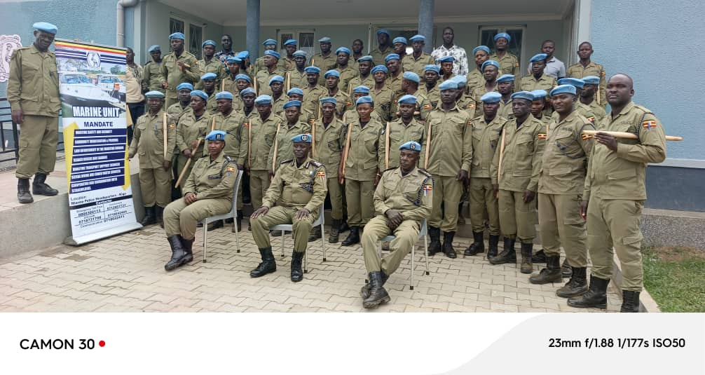
pic 2: The pass out ceremony for newly promoted corporals was conducted to officially confirm their new ranks and responsibilities

⚓ Prepared by:
ASP KAGIMU MOSES
Data Officer – Uganda Marine Police

APPENDICIES
APPENDIX 1
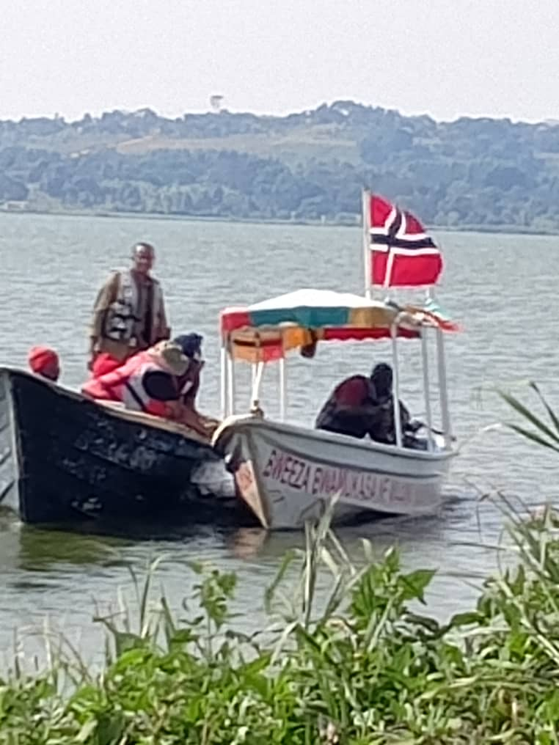
pic 3:Police officers from the Entebbe Marine Unit rescued stranded passengers on Lake Victoria

Appendix 2
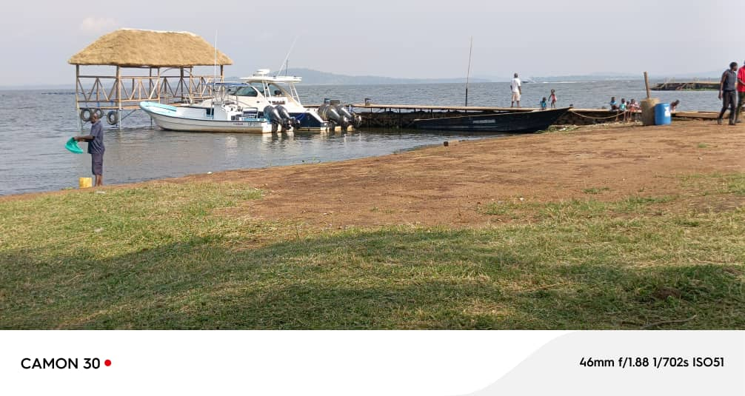
pic 4: Newly Constructed Temporary Pier at Kigo Marine base

